UnBSense Project Process

1. Introduction

1.1 Purpose
This document describes the process followed by project UnBSense, our under-development platform to identify possible signs of psychological distress on social media, with the goal of empowering suicide preventing efforts by institutions and governmental agencies.

1.2 Definitions, Acronyms, and Abbreviations
See the UnBSense Glossary (UnBSense-GLO) for a comprehensive list of terms used on this project.

1.3 Overview
Project UnBSense follows the Agile Methodology process configuration, not binding or being restricted to any specific approach, such as Scrum or Kanban.
The remainder of this development case addresses this project’s main artifacts:
i) Project Plan | ii) Work Items List | iii) Risk List | iv) Iteration Plan
v) Vision | vi) Glossary | vii) Use-case Model | viii) Use Case
ix) Tools | x) Architecture | xi) Infrastructure | xii) Prototype

2. Life Cycle
The UnBSense Project adopts the standard life cycle described in Agile Model SDLC. Thus, the life cycle is both iterative and incremental, in one to three-week span increments.
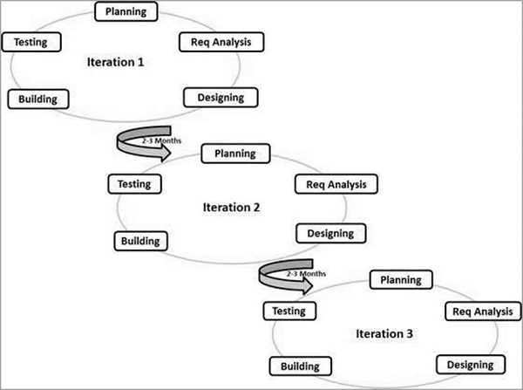

3. Practices
The UnBSense project will follow the standard best practices defined by the Agile Methodologies. Those best practices include
- Individuals and interactions − In Agile development, self-organization and motivation are important, as are interactions like co-location and pair programming.
- Working software − Demo working software is considered the best means of communication with the customers to understand their requirements, instead of just depending on documentation.
- Customer collaboration − As the requirements cannot be gathered completely in the beginning of the project due to various factors, continuous customer interaction is very important to get proper product requirements.
- Responding to change − Agile Development is focused on quick responses to change and continuous development

4. Work Products
In line with Scrum Project Management, the UnBSense Project will dispose of the following work products:
- Product Backlog - The Product Backlog is a document that lists and prioritizes the required features and constraints of the product to be build.
- Sprint Backlog - The Sprint Backlog is a document that lists the tasks to be performed as part of a Sprint.
- Burn-Down Chart - A Burn Down Chart is a publicly available document charting the progress of the team in building the product.
- Increment of Product Functionality - An Increment of Product Functionality is a potentially deployable software that contains more and more features and functions, useful to its users.

5. Reports
Respecting the Agile life cycle guidelines adopted in this project, reports will be generated at the end of each iteration (one to three weeks), so as to empower the team to make better projections for the next Sprint. Some valuable reports are:
- Sprint Burn-down - is a graphic representation that shows the rate at which work is completed and how much work remains in the current Sprint.
- Version Burn-down – is a graphic representation that shows the rate at which work is completed and how much work remains in Product/Version Backlog.
- Control Chart – focuses on the time cycle of individual issues – the total time from "in progress" to "done", in order to measure the team’s throughput.
- Automated Test Coverage – measures the percentage of code under the scope of automated test coverage.
- Bugs in Production and Deferral – measures the amount of incoming bugs during development and production, and the amount of bugs left to be solved in future versions.
- Costumer Request Volume – accounts for all users’ requests for functionality, changes or issues they might have with the product.

6. Roles
Mainly four key roles will be used throughout the iterations of our project’s SDLC:
- Stakeholder - is anyone who is a direct or indirect user, manager of users, senior manager, operations staff member, the "gold owner" who funds the project, support (help desk) staff member, auditors, your program/portfolio manager, developers working on other systems that integrate or interact with the one under development, or maintenance professionals potentially affected by the development and/or deployment of a software project.
- Product Owner - is the one person on a team who is responsible for the Product Backlog, for making decisions in a timely manner, and for providing information in a timely manner.
- Team Lead - is responsible for facilitating the team, obtaining resources for it, and protecting it from problems. This role encompasses the soft skills of project management but not the technical ones such as planning and scheduling, activities which are better left to the team as a whole.
- Team Member - is responsible for the creation and delivery of a system. This includes modeling, programming, testing, and release activities, as well as others.

